**SSH to your AWS Workstation**

**ssh devops@<public-ip-addr**> of your Workstation  
Password is : **Dev0p$!!/**

**Replace <your-name> with your name throughout the lab.**

1. Clone the **Git Repo** that contains the code.

|  |
| --- |
| $ mkdir Dockerfile  $ cd Dockerfile/  $ git clone <https://github.com/LovesCloud/Dockerfiledemo.git>  $ cd Dockerfiledemo |

**2.** Create a Dockerfile

|  |
| --- |
| $ vim Dockerfile |

3. Pate the below code to the **Dockerfile** and save the file

|  |
| --- |
| FROM nginx:1.13.7 COPY index.html /usr/share/nginx/html COPY . /usr/share/nginx/html RUN echo "Copying index.html to Container"  RUN echo "Preparing the new container" |

Press **esc key** then **:wq** and hit **enter** to exit

4. Run the below command to build the container.

|  |
| --- |
| $ docker build . -t dockerfiledemo-<your-name> |

5. Verify that the image has been build

|  |
| --- |
| $ docker images |

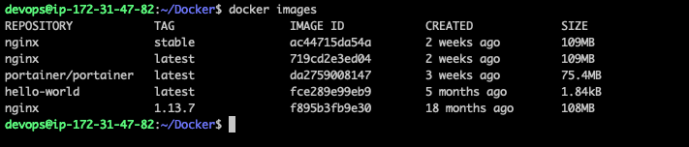

6. Run a container from the Image created

|  |
| --- |
| $ docker run -d -p 80:80 --name dockerfiledemo-<your-name> dockerfiledemo-<your-name> |

7. Check the docker container details.

|  |
| --- |
| $ docker ps |



8. Goto the browser and browse the host on default port 80 to test.

**http://<public-ip-of-your-workstation>**

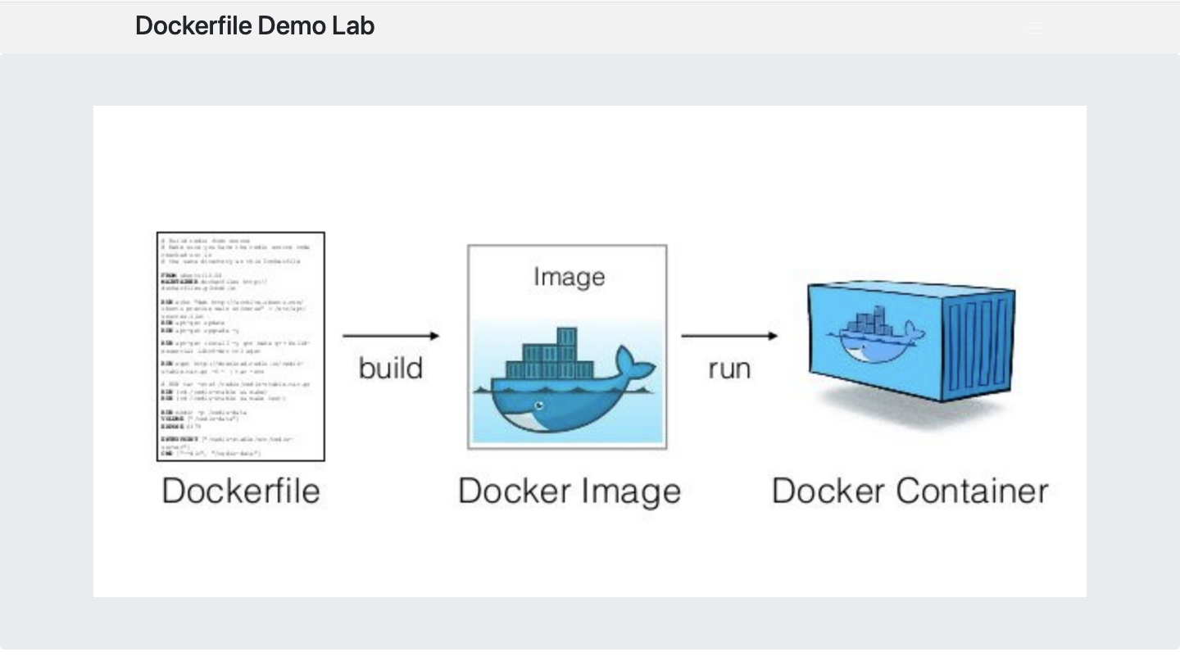

9. STOP the containers before proceeding to the next lab

|  |
| --- |
| $ docker stop dockerfiledemo-<your-name>  $ docker rm dockerfiledemo-<your-name> |